FOSSBilling Setup & Product Configuration Report (Business Lead)

1. Introduction
In this project, I was responsible for setting up the billing system for our cloud service using FOSSBilling. The goal was to create a fully functional system where customers can register, select VPS plans, and complete payments using Stripe.

2. System Setup
VM created on Proxmox (2 CPU, 2GB RAM, 20GB disk, Ubuntu).
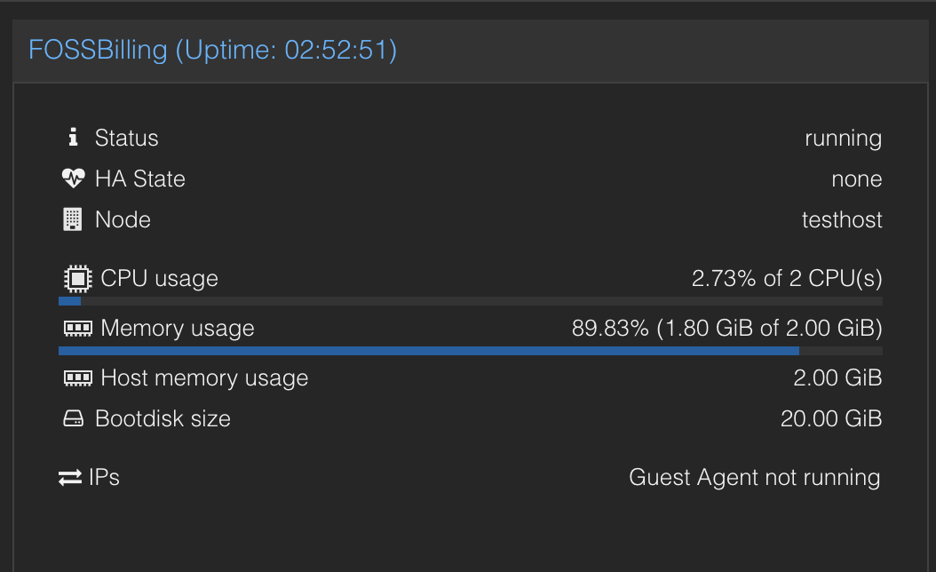

FOSSBilling installed
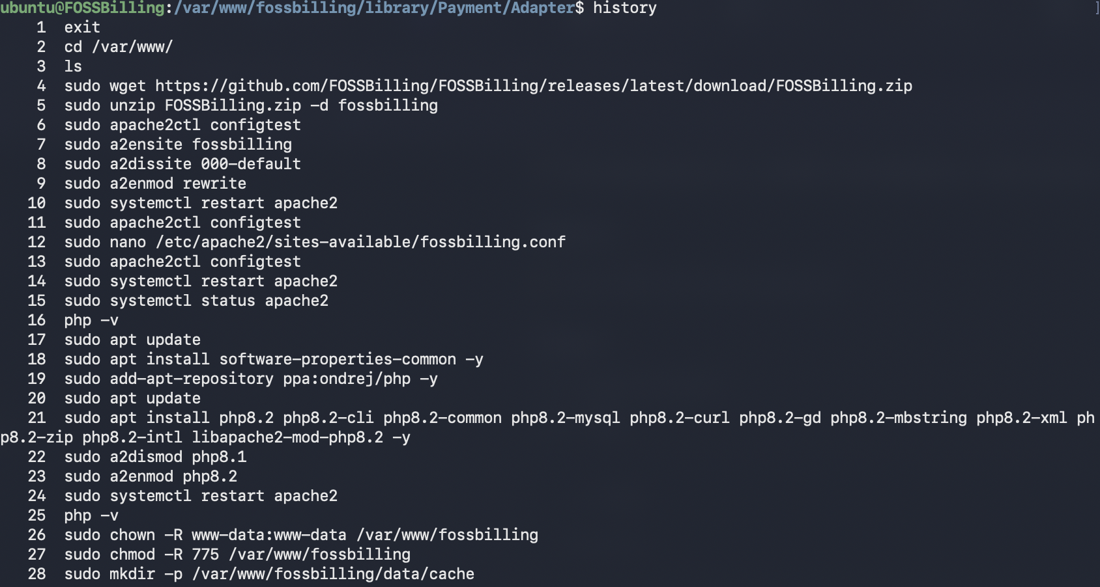
FOSSBilling installed and configured.
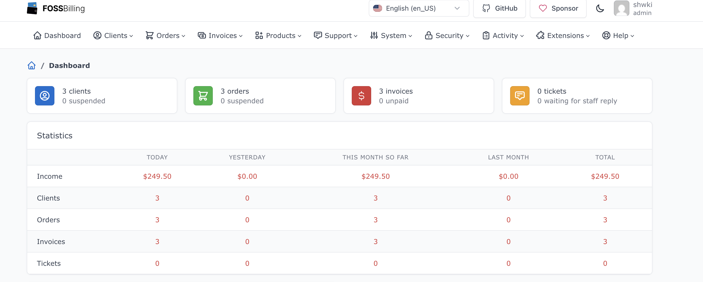
Cron job configured:
* * * * * php /var/www/fossbilling/cron.php
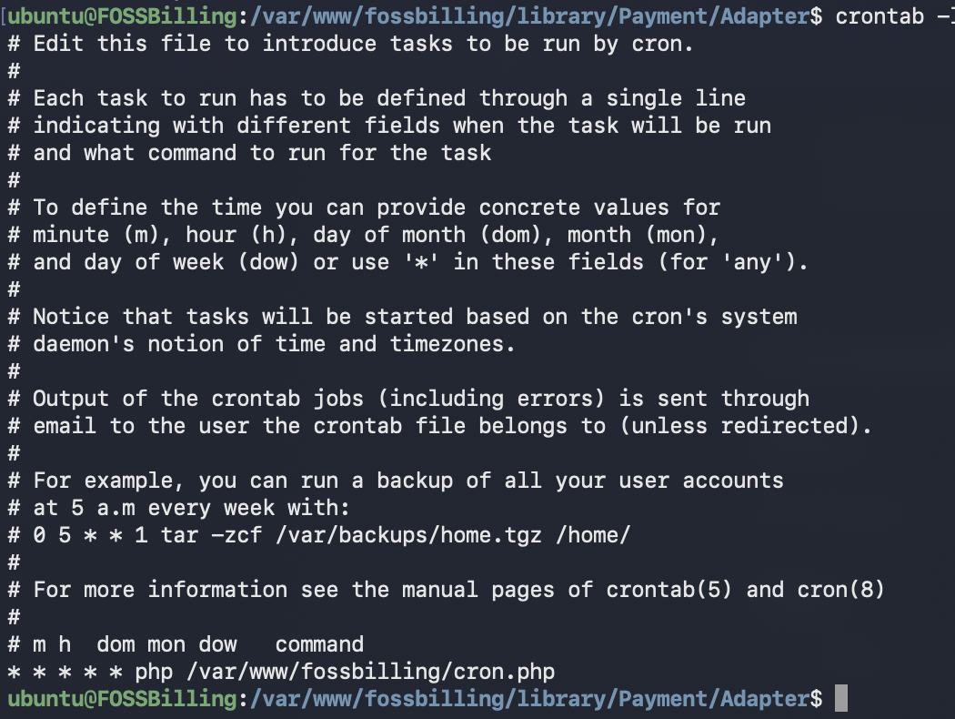

3. Product Configuration
Category: VPS Hosting
Products created:
- Micro VPS ($5/month, 1 CPU / 1GB RAM)
- Small VPS ($10/month, 2 CPU / 2GB RAM)
- Medium VPS ($20/month, 4 CPU / 4GB RAM)
- Large VPS ($40/month, 8 CPU / 8GB RAM)
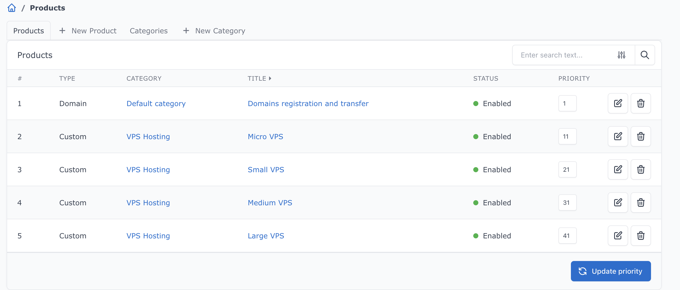
Recurring pricing configured.
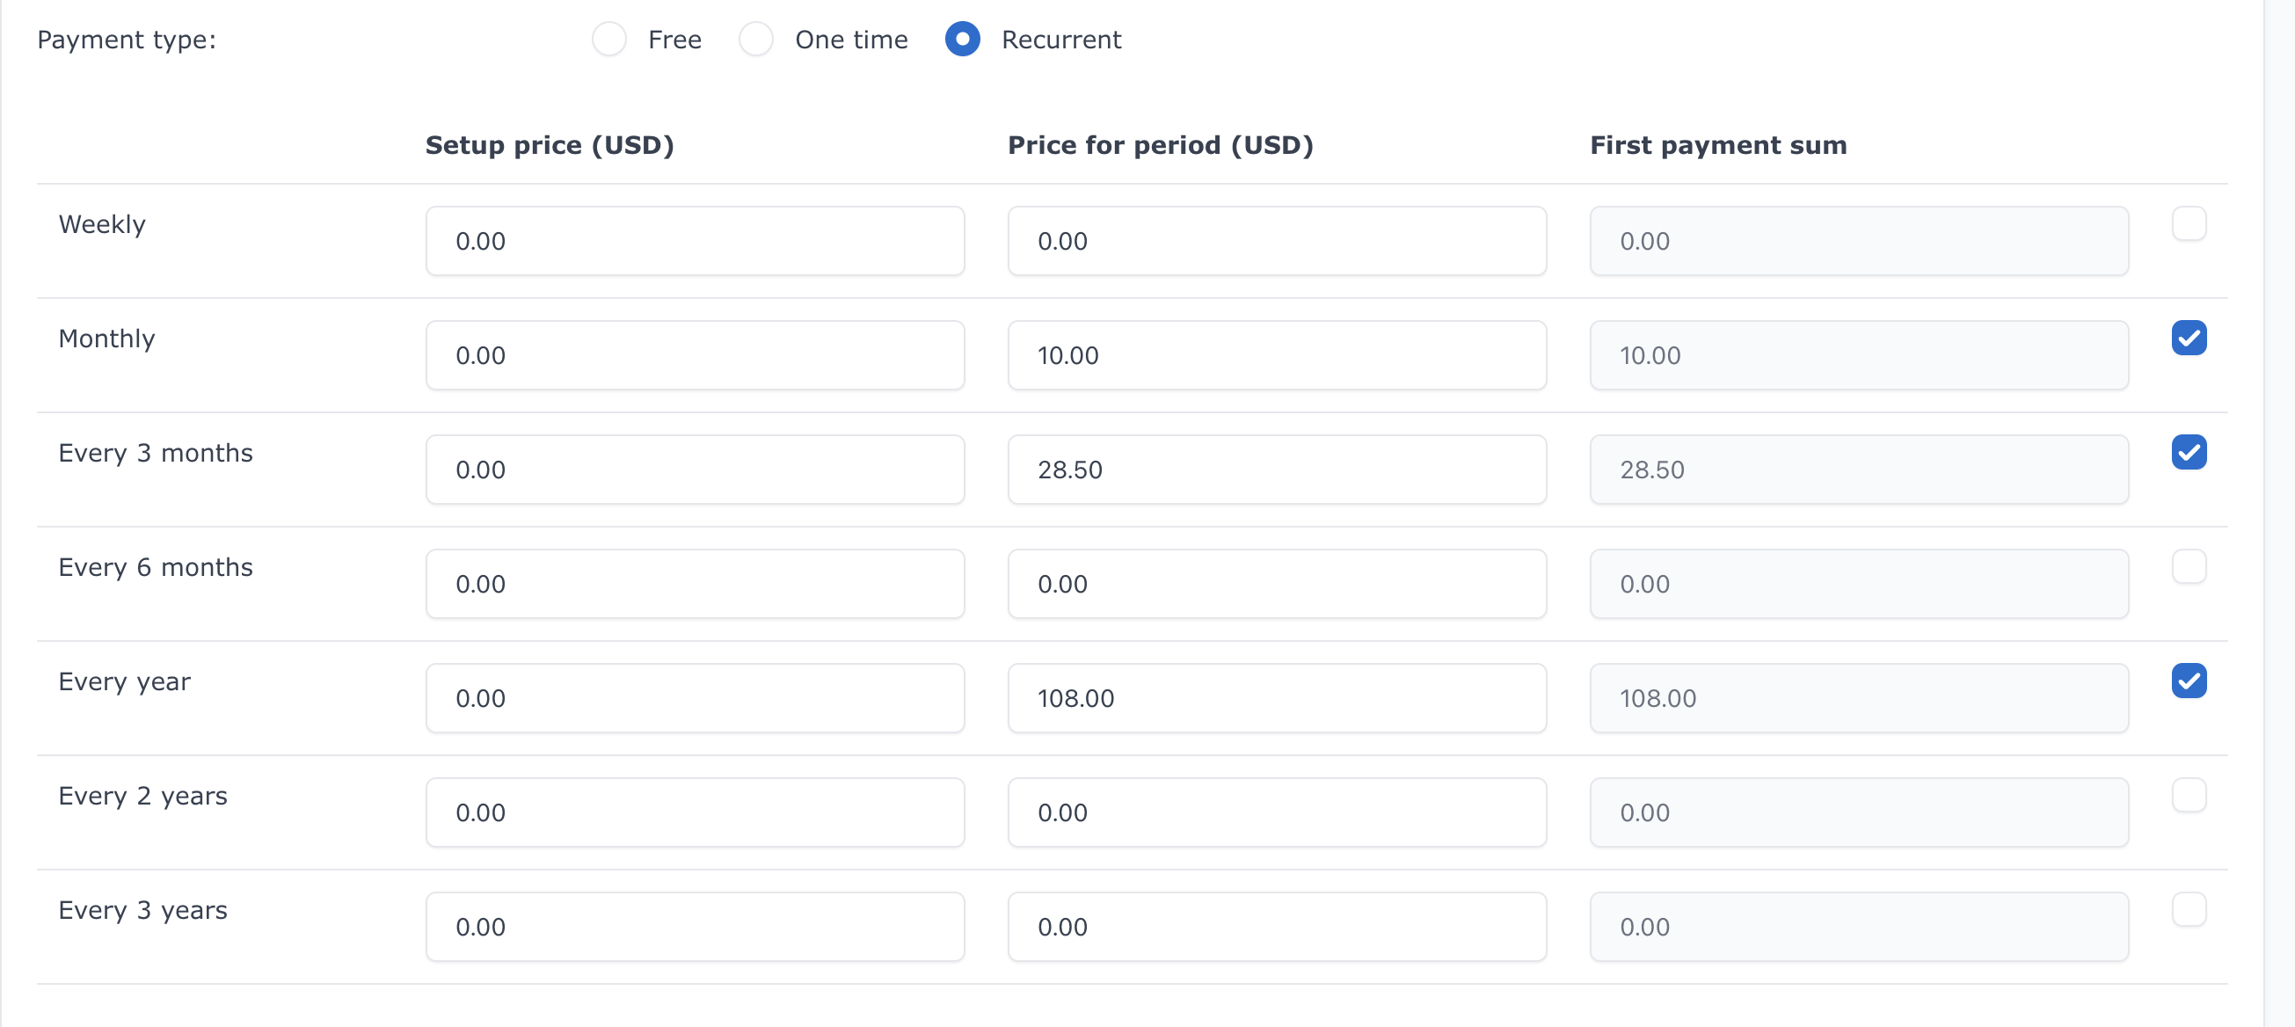

4. Payment Gateway Setup
Stripe configured in test mode using API keys.
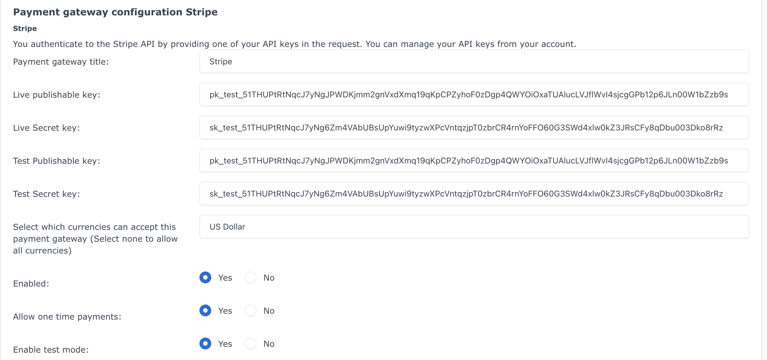
Payment tested using Stripe test cards.
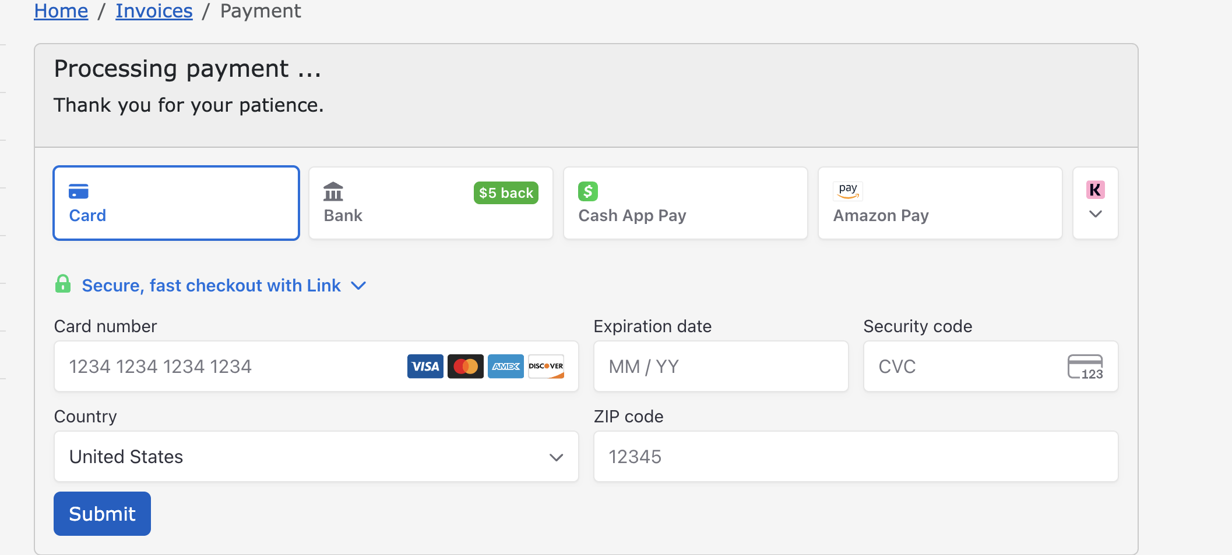

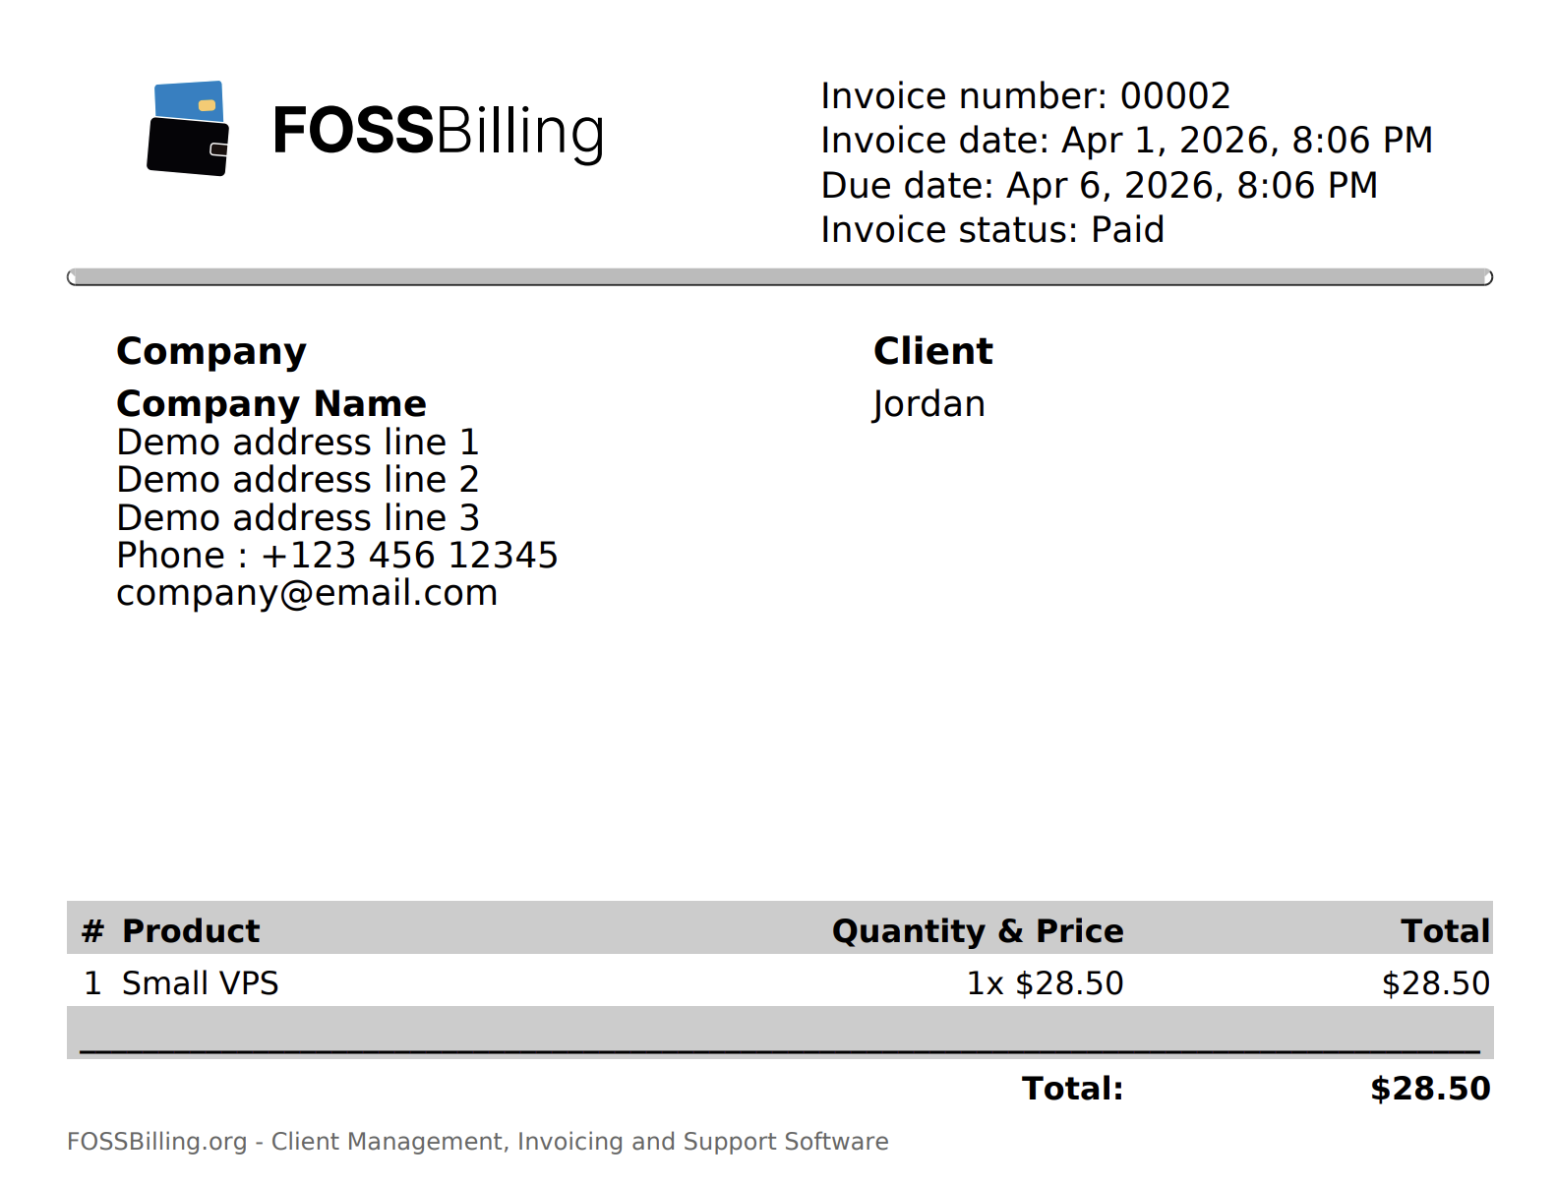

5. Testing & Validation
Customers created, orders placed, payments verified.
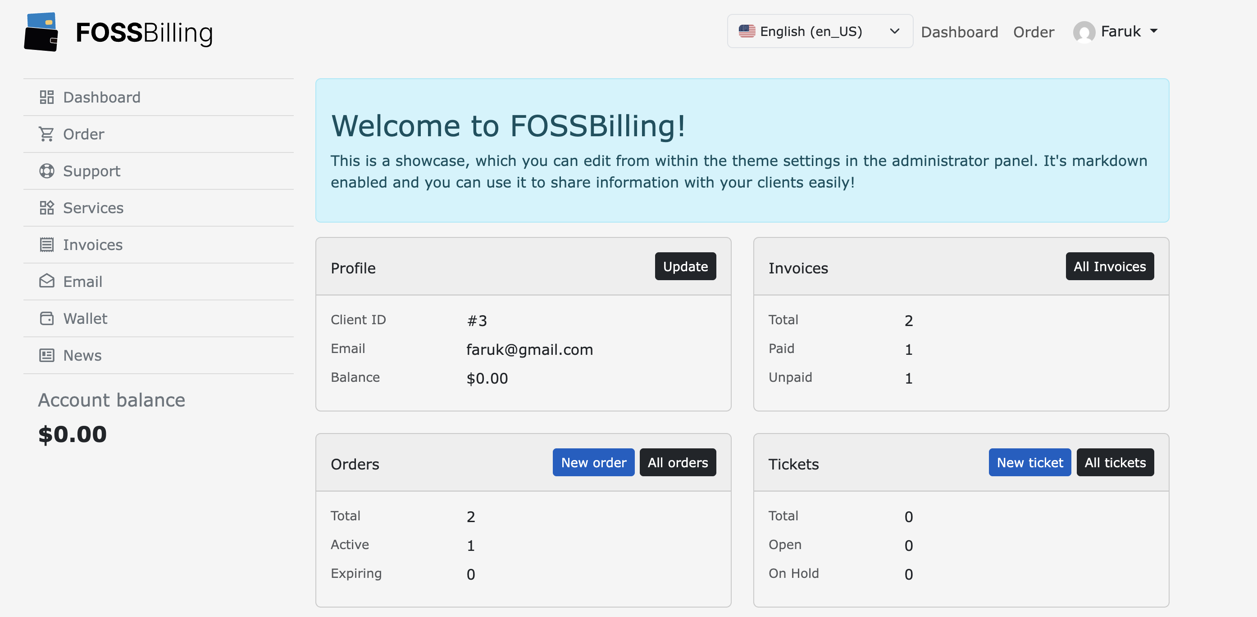

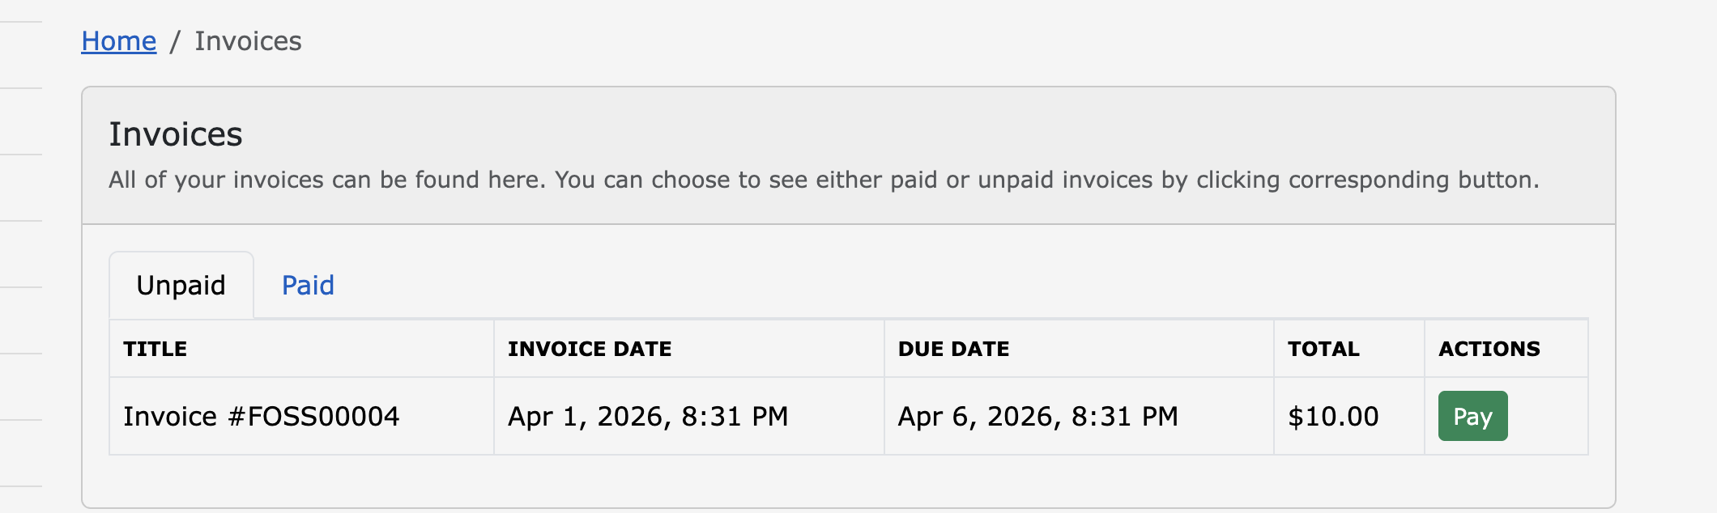

Stripe API Keys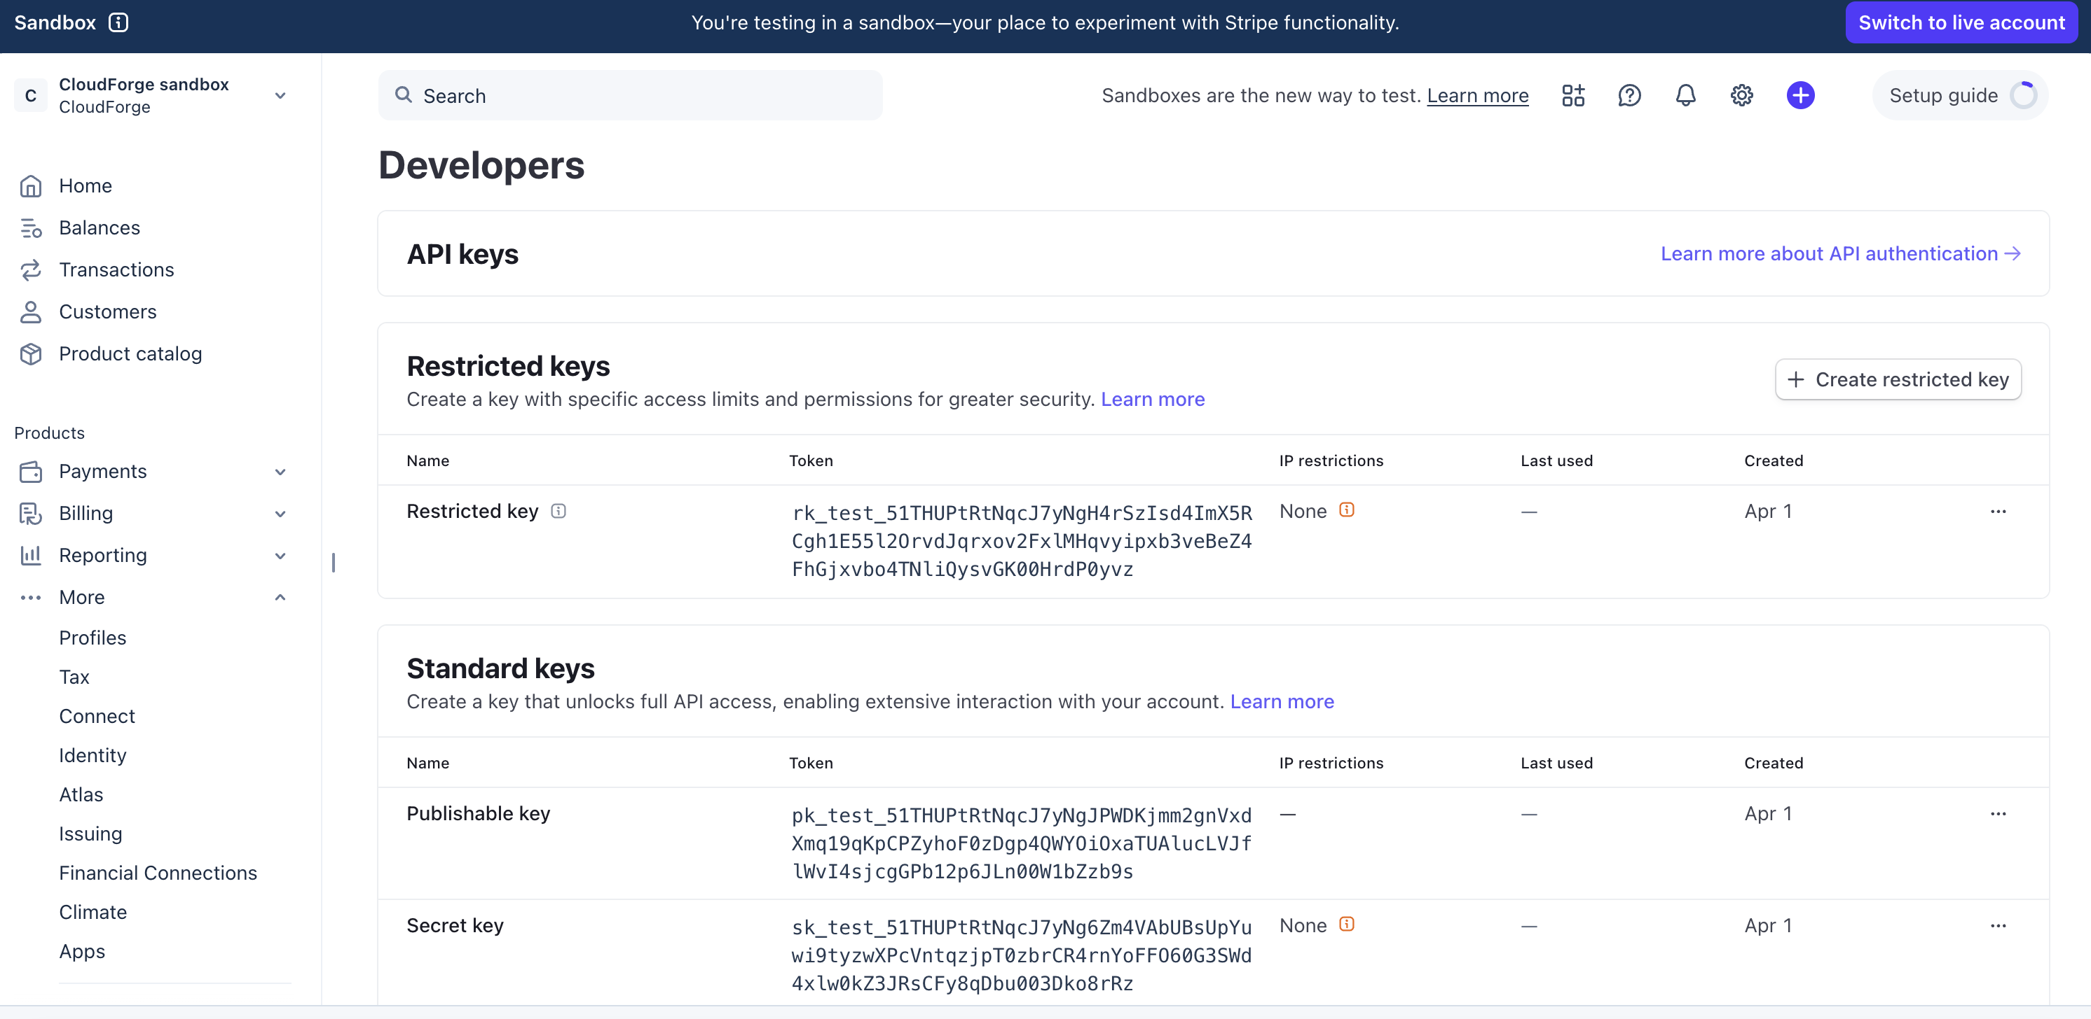

6. Fossbilling Info

FossBilling VM SSH login/passwd: ubuntu@192.168.0.195 - shwki12345

Netdata: http://192.168.0.230:19999
FossBilling admin: http://192.168.0.195/admin
FossBilling client: http://192.168.0.195

Emails/passwd Fossbilling admin:
Braden -btcooper@gmail.com Bb12345678 / will change
Jordan -jordansteele1316@gmail.com Jj12345678 / will change
Donovan -Donovan@gmail.com Dd12345678 / will change
Shwki -shwki@gmail.com Shwki12345

Test/dummy Fossbilling client email/passwd:
- Name - Ahmed
User - Ahmed@gmail.com
Pass - Aa12345678
- Name - Jordan
User - Jordan@gmail.com
Pass - Jj12345678
- Name - Faruk
User - Faruk@gmail.com
Pass: Ff12345678

